Grade 2 Unit 1: Landscape Shapes
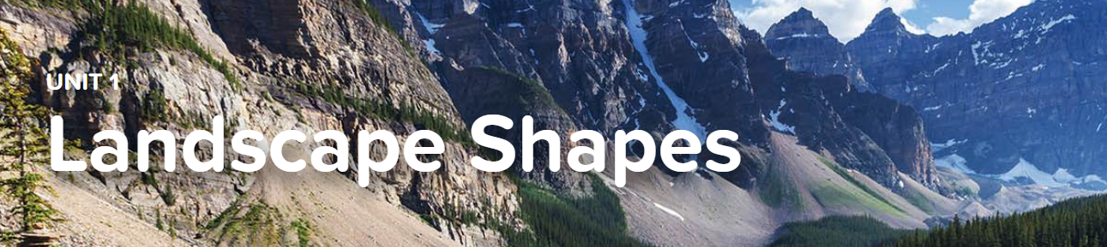

Concept 1.1 Local Landscapes
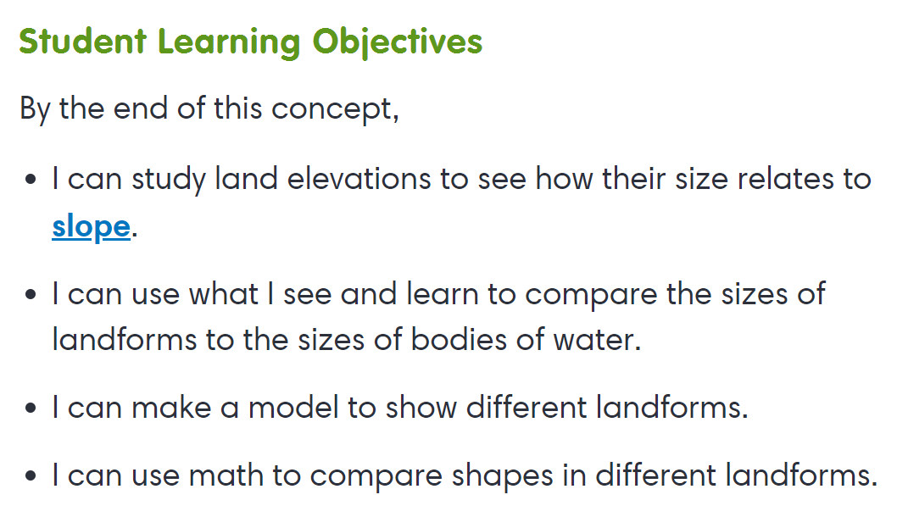
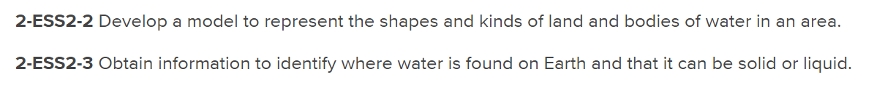
Virtual Lab
- Here Today, Gone Tomorrow

Concept 1.2 Mapping Landscapes
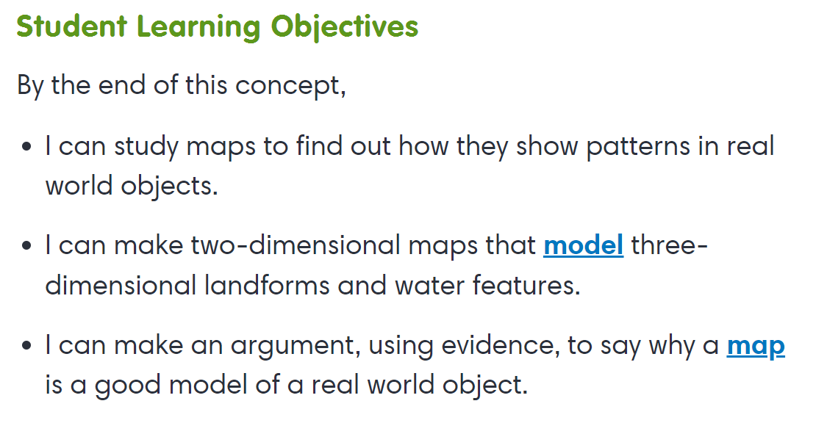

Concept 1.3 Land and Water Relationships
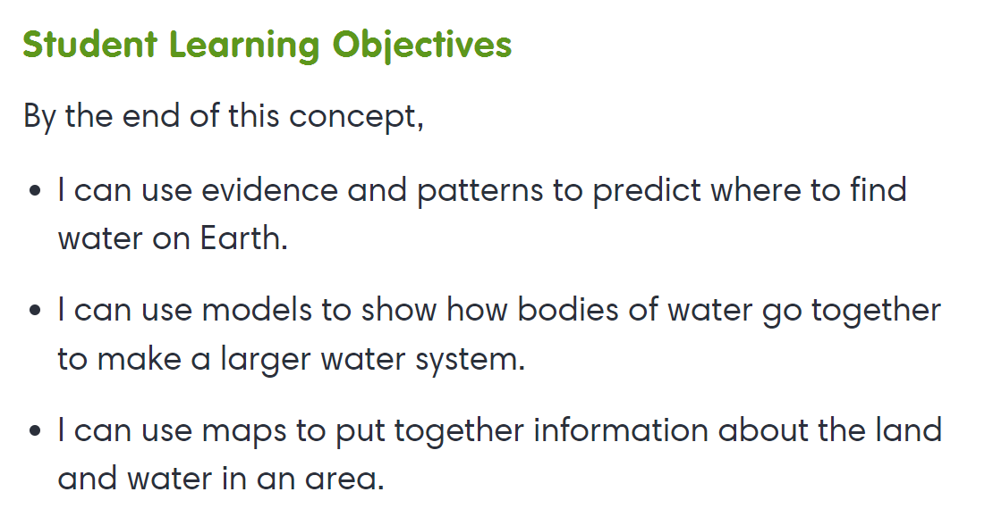
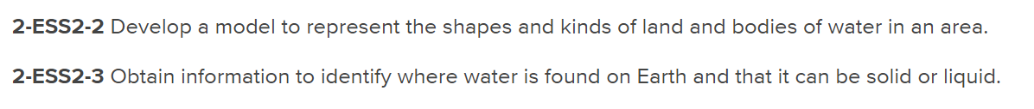
Interactives
- Waters of the Earth

